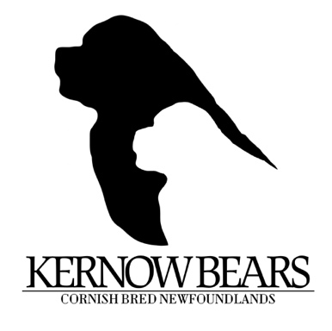

Kernowbears puppy buyer checklist
Here at Kernowbears we take making sure we find the right family for our puppies very seriously. We have a certain style and way of doing things that may not suit some owners (being chaotically disorganised with paperwork being one of our quirks) and long term contact with our owners is extremely important to us. Therefore, it is essential that we make sure that we are the right breeder for you and you are the right family for us.
This enquiry form will help us to determine what your knowledge of the breed is, what kind of life you lead and what circumstances our puppy would be in. The more information you include the better.
We always follow up with a (long) phone call when we have read through the form and we hope that you will have read through all the information that we included about us and Newfoundlands in general.
If you are on social media we ask that you add us as a friend so that we can have a window into your lifestyle. As our puppies are everywhere in the UK from the top of Scotland down to Lands End in Cornwall it enables us to do a virtual ‘home check’. If you aren’t comfortable with that, we probably are not the breeder for you. That is ok, we understand everybody is looking for different things from their breeder and we know some very reputable Newfoundland breeders that we can direct you to.

Before your first visit you will need to supply us with photo ID and your car registration number, this is purely for security purposes and will not be retained by us.
Full name of applicant.
Full address

Phone/mobile number
Email address

Have you received the breed information pack and breed standards information and do you have any concerns or questions?

Have you owned a Newfoundland or other giant breed before? If so please tell us more about your giant furball.

Have you properly researched the breed? How?

How many people live in your household and what ages are they?

What other animals live in the household? Type of animal, breed and age?

Do all members of the household work? If so for how many hours a week and what dog care arrangements do you have in place.

Have you researched the cost of health insurance for a Newfoundland – it is part of the Kernowbears contract that all puppies are insured, and we ask that you send proof of this prior to collection day.

How much grooming and general care do you think a Newfoundland needs? How are you going to groom them, yourself – if so what equipment will you buy? At a groomers – if so how often and have you researched the cost.

Are you willing to sign an contract that states you MUST keep your Newfoundland at a health slim weight, do you understand why we insist on this.

Are you willing to commit to not neutering your dog until it is at least 2 years old to enable it to grow properly?

Are you willing to commit to the diet and exercise advice that we give all owners to give their puppy the best chance of developing into a healthy adult.

Are you happy that all Kernowbears are sold as pets and will be endorsed against breeding? If you have a particular interest in breeding that can be discussed, but would only be considered if the puppy had passed all of the breed club recommended tests and you were willing to sign a breeding contract to ensure that you would breed responsibly?

What type of home do you have for your new puppy? For example, bungalow, split level etc.

Are you aware that Newfoundlands are mud magnets and keen gardeners and as such are not suitable for anyone who is house-proud or loves their garden? What plan do you have for dealing with this? (we have flowers behind stock fences and mop our walls….)

Does it have an enclosed and safe garden? Can you provide photographs?

Where will your puppy sleep?

What type of training do you plan for your puppy? Will this be followed by all adults and children in the household consistently?

Are you happy to send me pictures of your puppy set up?

Are you happy to post updates in the Facebook private owners group and update me on your puppies progress and development with you?

Why have you chosen a Kernowbears puppy?

Do you have a gender preference for your puppy?

Do you have a colour preference?

Can you continue to accept responsibility for the dog despite inevitable life changes such as new babies, kids going off to school, moving or returning to work/changing work needs? Are you prepared to sign our contract that insists on a return to breeder policy if you find yourself in a position where it is impossible for you to keep your Kernowbear?
If you have considered all the factors associated with puppy ownership and the responsibilities that go with it, answered ALL of the questions appropriately then we will be contacting you to have a chat and let you ask us all of the questions we have no doubt you will want to ask. Remember, the right puppy IS worth waiting for.

Personal name and address

Telephone number Mobile Phone
Email

Date of completion Suitable to go on waiting list YES ? NO

PREFERENCE: BOY GIRL Do you want to breed? YES/ NO
Preference: Brown Black Other

